PROJECT NOTES☘️
Who: 3–4 people per group;
What: Develop a Python software able to predict the type of interaction (contact) between protein residues (e.g., hydrogen bond, VdW, salt bridge, etc.) starting from a 3D protein structure (PDB), using statistical or machine learning methods → NN could be a very good alternative (others?) :
- Do not use RING;
- A Naive Bayes model is provided as an example (classifier.ipynb) → your model must perform better.

Report e Documentation: Paper (2-4 pages of text, excluding figures) + Markdown.

Oral exam:
- Project: each member should explain one part (e.g., Introduction, Methods, Results);
- Theory: very general (no details, no formulas and so on …).

—--------------------------------------------------------------------------------------------------------------------

Project Specifications
Structural Bioinformatics - University of Padova

Classification of contacts in protein structures

Introduction
Residue Interaction Networks are derived from protein structures based on geometrical and physico-chemical properties of the amino acids. RING (https://ring.biocomputingup.it/) is a software that takes a PDB (https://www.rcsb.org/) file as input and returns the list of contacts (residue-residue pairs) and their types in a protein structure. RING contact types include:
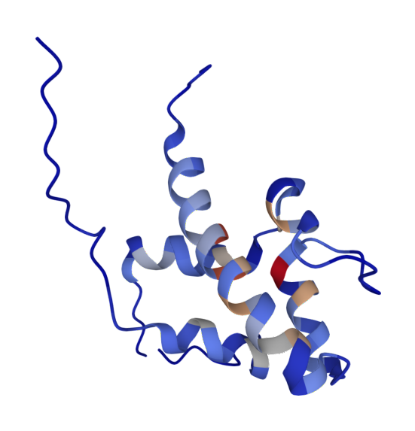
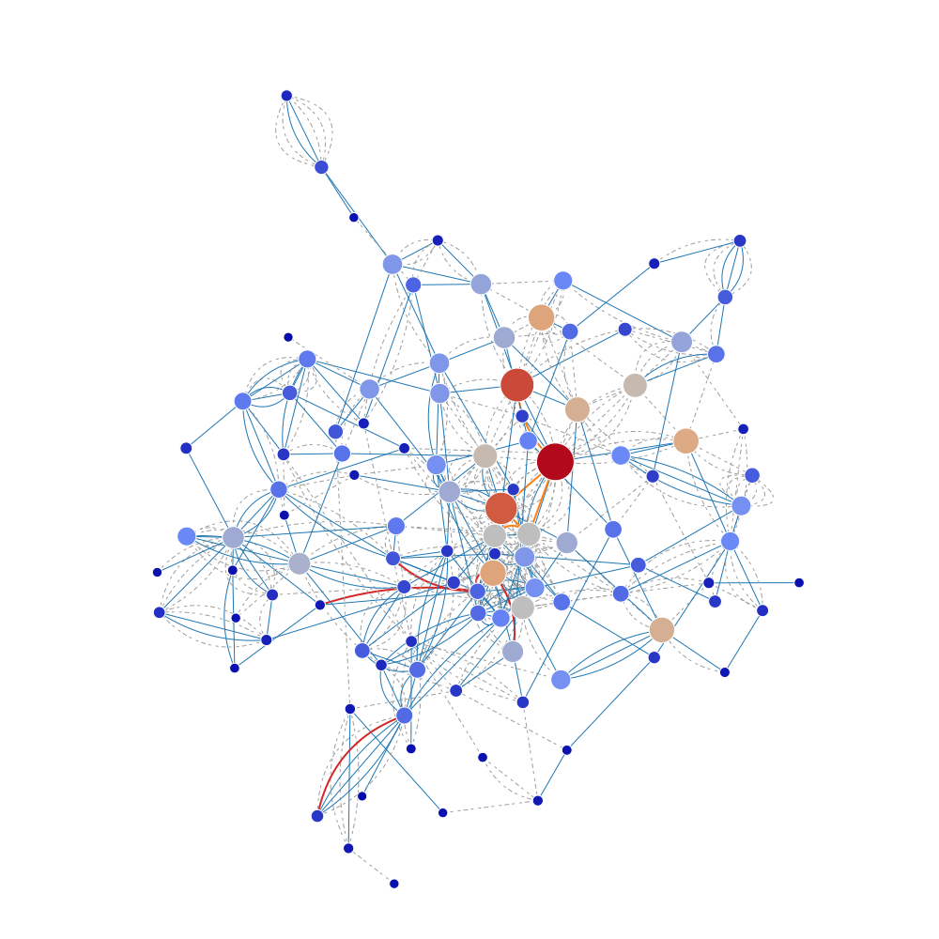
- Hydrogen bonds (HBOND)
- Van der Waals interactions (VDW)
- Disulfide bridges (SBOND)
- Salt bridges (IONIC)
- π-π stacking (PIPISTACK)
- π-cation (PICATION)
- Hydrogen-alogen (HALOGEN)
- Metal ion coordination (METAL_ION)
- π-hydrogen bond (PIHBOND)
- Unclassified contacts -> HOW MANAGE THEM (delete, consider as negative samples, manage in some way ecc ?..). In these cases, RING not consider them as contacts

And for the overlapping situation? Cosa fare per i contatti che si sovrappongono? Va definito un modo per definire entrambi (posso valutare l’area del overlap … )

CLASSI: RING SULLA BASE DI PROPIETA’ GEOMETRICHE
CONTRATTI: BIOPYTHON USANDO LE DISTANZE
Each group of students has been tasked with developing software that can predict the RING classification of a contact based on statistical or supervised methods, rather than geometrical constraints. The program should be able to calculate the propensity (or probability) of a contact belonging to each of the different contact types defined by RING, starting from the protein structure.
In addition to the software, each group of students is requested to provide a report that describes their implementation and the results obtained from analyzing the provided dataset. The report should also include interesting examples that demonstrate the correctness of the calculation and help to convince the reader of the accuracy of the results.

Data and code
- classification_ring.zip - Feature extractions software along with a naive predictor as an example
- features_ring.zip - Training data archive -> training set

Features extraction
I provide two Python scripts calc_features.py and calc_3di.py that can be used to extract some features from PDB files and 3D contacts with the built-in BioPython modules.

-> Keep inspiration from these 2 scripts to calculate the feature and generate the prediction.

calc_features.py
- Not necessarily the ramachandran values bsc we already have phi and psi
- TODO add sequence separation: We must consider if is a parameter for our training (potrebbe essere utile).

The first script calculates structural properties (secondary structure, relative solvent accessibility, half-sphere exposure, Atchely’s scales). The second script converts the PDB sequence into the 3Di alphabet used by FoldSeek.

3Di: traduce l’alfabeto delle proteine in uno + lungo che cattura la structure environment delle proteine

The scripts can be executed with the following command:

$python3 calc_features.py my_pdb.cif -out_dir output_features/
$python3 calc_3di.py my_pdb.cif -out_dir output_3di/

Note that calc_features.py requires the DSSP program that only works on POSIX operating systems (not on Windows). Please check the paths in the configuration.json file.
Also note that calc_3di.py contains a variable that defines the position of the model files you need to modify depending on where you execute it.

All or some of the features calculated by the program can be used for training. Additional features can be calculated, if desired. Some features, such as the secondary structure, capture the local environment of the residues, while others, like Atchley, capture the physico-chemical properties of the amino acids. The 3Di FoldSeek encoding is calculated looking at the local environment of the contact in the 3D space.

Training set
Training data is provided in separate files, one for each PDB structure that has been generated by executing the two feature scripts (see above) and merging their outputs. All the files together (3,914 PDBs) contain the following numbers of contacts:

Contact type | Count
HBOND | 1,055,929
VDW | 737,061
PIPISTACK | 38,283
IONIC | 35,391
PICATION | 8,885
SSBOND | 2,100
PIHBOND | 1,790
Unclassified | 1,089,547

Every file is a tab-separated table with the columns below. Columns specify residue identifiers (same fields used in BioPython), pre-calculated features and the type of interaction (last column). This table differs from the one generated by the provided calc_features.py program just by the “Interaction” column (last column).

Column name | Column meaning | Type of column
pdb_id
s_ch | chain | source residue identifier
s_resi | index
s_ins | insertion code
s_resn | name
s_ss8 | secondary structure 8 states (DSSP) | source residue features
s_rsa | relative solvent accessibility -> depend with the location
s_phi | phi angle
s_psi | psi angle
s_a1 | Atchley feature 1 -> captures le AA properties (idrogobici/idorfilici)
s_a2 | Atchley feature 2
s_a3 | Atchley feature 3
s_a4 | Atchley feature 4
s_a5 | Atchley feature 5
s_3di_state | 3Di state use (one of the two is stuff (redondant info)
s_3di_letter | 3Di alphabet
t_ch | chain | target residue identifier
t_resi | index
t_ins | insertion code
t_resn | name
t_ss8 | secondary structure 8 states (DSSP) | target residue features
t_rsa | relative solvent accessibility
t_phi | phi angle
t_psi | psi angle
t_a1 | Atchley feature 1
t_a2 | Atchley feature 2
t_a3 | Atchley feature 3
t_a4 | Atchley feature 4
t_a5 | Atchley feature 5
t_3di_state | 3Di state
t_3di_letter | 3Di alphabet
Interaction | interaction type

Predictor
The predictor software requires a PDB file as input, extract the features and generates an output table including the contact identifiers, their features, the interaction type and the score (one line per contact; tab separated columns):

Source_residue_clumns (chain, index, insertion code, name)
Target_residue_columns (chain, index, insertion code, name)
Features_columns (...)
Interaction (hbond/vdw/...)
Score

Training can be performed by generating different individual models for each type of contact, i.e. training each class separately or as a multi-class model. Negative examples can be contacts of a different type (for single-class models). Alternative strategies can also be adopted. An example of a Naive Bayes classifier called classifier.ipynb is provided in the same archive as the calc_features.py program.

Similar to statistical potential: Try to learn distribution. There are 2 problem here:
- These predictor assumes that the feature are independent
- For the same pairs of AA forming a contact we can have multiple contacts (ex. HB + VDW by def). There are multiple alternatives that we can use to manage this situation (keep only one class for every contact, exclude VdW, exclude the overlapping contact ecc …).
- This type of model is not the best when the same pair of AA forming multiple contacts (+ classes) bcs predicts the class with a maximum score.

Naive Bayes classifier:
- categorie problematiche: le piu' abbondanti (VDW, Missing e HBOND)
- In the matrix the overlap are count 2 times
- Ideal predictor: all zeros and 1 on the diagonal (it is not this the case)

Usel thing to do: check if the FP can be TP (i.e. check the real contacts with PYMOL) -> Compare real examples to understand if RING is not able to capture some real situations.

Goal: Demonstrate that our method is much better than random (ex. NN is good to predict very specific case)
- Exploit Biopython to find contacts and use our predictor to classify them (without RING).

Project requirements
- A software implemented in Python3 for the prediction of contact types given a protein structure. The use of the BioPython.PDB, Argparse and Logging modules is encouraged. All paths to data files (e.g. models), paths to external tools (e.g. DSSP) and hyperparameters have to be provided in a configuration file. Use of the RING software is forbidden and will be checked by the teacher.
- The trained models and the script (or program) to generate (train) them. Training has to be fully reproducible. Model evaluation can be provided using data provided in the training set and performing cross-validation.
- A report that provides a detailed explanation of the adopted strategy (algorithm, etc.), statistics of the features (distribution, correlation, etc.), and an evaluation of the software. The report should be provided in PDF format and be between two and five pages of text, excluding figures and supporting documentation.
- Documentation of the software, including information about how to use it and instructions about how to re-train the models. The documentation should be provided in Markdown language.

Project evaluation
- The algorithm will be blindly tested against a validation dataset not available to the students. Matthew's correlation coefficient, balanced accuracy, average precision score and area under the ROC will be considered. The predictor performance should be significantly better than random.
- Reproducibility of the training will be evaluated along with the performance.
- Clarity of the documentation, reproducibility of the results, and the quality of the reporting will also be evaluated.

—--------------------------------------------------------------------------------------------------------------------

Useful observations
Similar missing values (%) between the interactions:
- The data quality or completeness is consistent for those columns;
- The cause of missing values depend of some intrinsic characteristic of the feature (and not based on the interaction);
- The missing values are distributed in a uniform way and do not depend on interaction type.
Different missing values between the interactions (like SS BOUND):
- The missing values depend of the type of interaction;
- Found this values is difficult for the examining interaction interaction;
- Error or missing values only for some specific interactions.

- RSA misura quanto un residuo è "esposto" al solvente (cioè all’acqua) rispetto alla sua esposizione massima teorica.
- Valori di RSA tipici:
  - RSA ≈ 0 → residuo completamente sepolto all’interno della proteina.
  - RSA ≈ 1 → residuo completamente esposto alla superficie della proteina.

2️⃣ Perché è utile calcolare la differenza di RSA tra i due residui di un contatto?
Perché la combinazione di quanto sono esposti i due residui ci dà un'informazione importante sul tipo di contatto che possono formare.
👉 Alcuni esempi:
- Due residui entrambi sepolti → più probabile un VDW o un disulfide bridge.
- Due residui entrambi esposti → più probabile un HBOND o un IONIC (tipici delle interfacce, che si trovano in superficie).
- Un residuo molto esposto + uno molto sepolto → contatto meno comune → pattern utile per il classificatore.
In generale:
- Se la differenza di RSA è piccola → i due residui sono "simili" in esposizione → pattern tipico di certi tipi di interazione.
- Se la differenza di RSA è grande → pattern più raro → può aiutare a discriminare certi tipi di contatto.

Gli Atchley factors sono cinque valori numerici che rappresentano le proprietà fisiologiche e chimico-fisiche degli aminoacidi in modo condensato.

2️⃣ Perché calcolare la differenza dei fattori Atchley tra i due residui?
- Le interazioni tra residui dipendono fortemente dalle loro proprietà chimico-fisiche.
- Calcolare la differenza (in valore assoluto) tra i fattori Atchley di due residui dà una misura della distanza chimico-fisica tra i due aminoacidi coinvolti nel contatto.
- Piccole differenze indicano residui simili nelle loro proprietà (ad esempio, entrambi idrofobici o entrambi polari).
- Grandi differenze indicano residui molto diversi, il che può influenzare il tipo di interazione possibile (ad esempio, un residuo carico interagisce probabilmente diversamente da uno apolare).

1️⃣ Cosa significa se le delta_atchley sono simili tra loro (tutte piccole o tutte grandi)?
- Se tutte le delta_atchley sono piccole → i due residui sono chimicamente simili in tutte le proprietà principali (idrofobicità, carica, polarità, ecc.).
  - Questo è tipico di interazioni come:
    - Van der Waals (VDW) → spesso tra residui idrofobici simili.
    - π-π stacking (PIPISTACK) → tra residui aromatici simili.
- Se tutte le delta_atchley sono grandi → i due residui sono molto diversi chimicamente.
  - Questo è tipico di interazioni come:
    - Ionic (IONIC) → tra cariche opposte (es. Lys e Glu).
    - π-cation (PICATION) → tra un residuo aromatico e una carica positiva.
- Se ci sono alcune delta_atchley piccole e altre grandi → i residui sono simili in alcune proprietà ma diversi in altre → questo pattern potrebbe caratterizzare specifiche interazioni più complesse, come HBOND.

MCC=[TP×TN−FP×FN] / sqrt[(TP+FP)(TP+FN)(TN+FP)(TN+FN)​]
Valori di MCC:
- +1 = predizione perfetta
- 0 = predizione casuale
- -1 = predizione totalmente errata (inverso)
In parole semplici, MCC misura quanto la predizione del modello è correlata con la realtà, considerando tutti e quattro i casi possibili.

